

CAMPUS SAFETY INFORMATION May 18, 2009
_____________________________________________________________________________________________________________________

Suspicious Person at the College Center

On May 18, 2009, at approximately 6:24 PM, the male suspect seen in the pictures below entered the College Center through the rear door. He walked past M&O, headed toward the Audio-Visual area, and then walked up the east stairwell to the 3rd floor. While checking the doors to DL and Military, the suspect was challenged by a Coastline staff member. The suspect claimed he was interested in taking classes, but seemed nervous and did not ask questions like a prospective student. On July 16, 2008, at approximately 5:00 PM, a similar incident occurred in which possibly the same suspect tried to steal some keys. If anyone recognizes the suspect(s), or if they are seen again at any of our sites, please contact Gary Stromlund at 714-241-6360 (Office) or 714-981-1958 (cell).

July 16, 2008
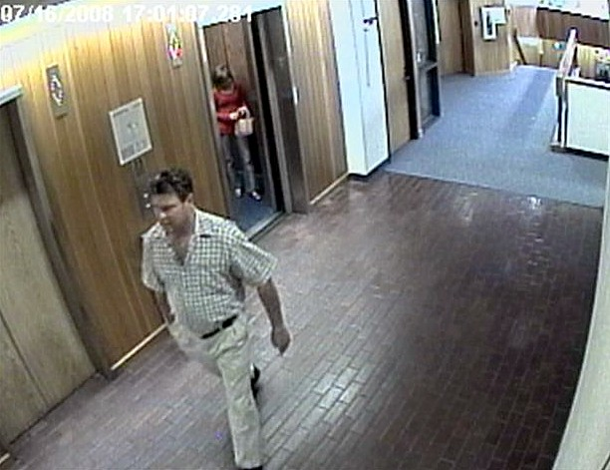

May 18, 2009


